**LAB # 9:**

**“ INTRODUCTION TO IMAGE PROCESSING ”**

* **OBJECTIVE:**

In this lab, you will learn the basics of image processing using Python. The tasks include: Loading an image, Resizing an image, Understanding image augmentation, applying an image augmentation technique, Detecting edges in an image, Converting an image to grayscale, Displaying a histogram of the image, Converting the image to an array and displaying the array.

* **LAB TASKS:**

**TASK 1:** Apply Brightness

* Load an image.
* Increase the brightness of the image.
* Display the original and augmented images.
* **CODE:**

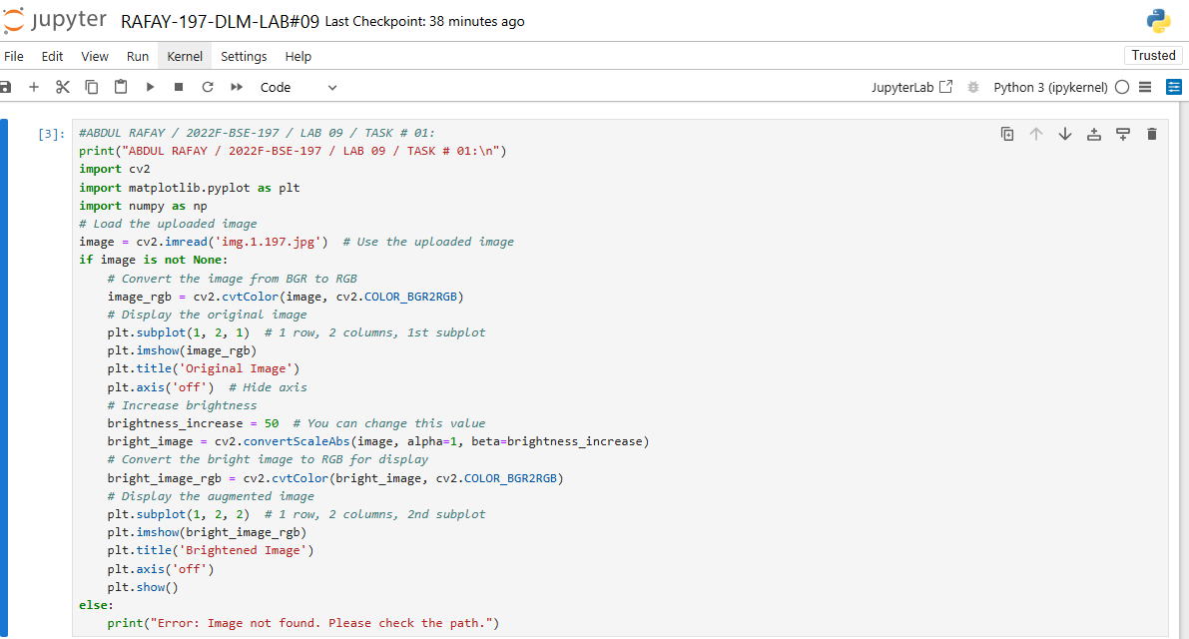

* **OUTPUT:**

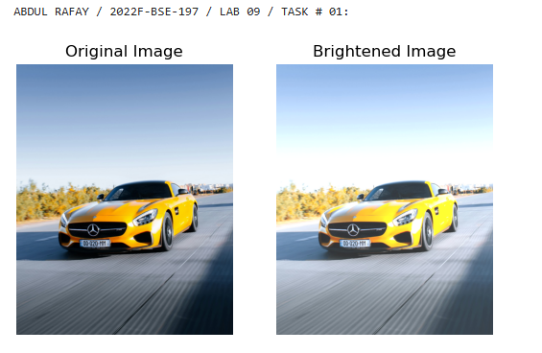

**TASK 2:** Apply Another Edge Detection Technique

* Load an image.
* Convert the image to grayscale.
* Apply the Sobel edge detection technique to the grayscale image.
* Display the original grayscale image and the Sobel edge-detected image.

**Hint:** Use the cv2.Sobel function in OpenCV to apply the Sobel operator:

* **CODE:**

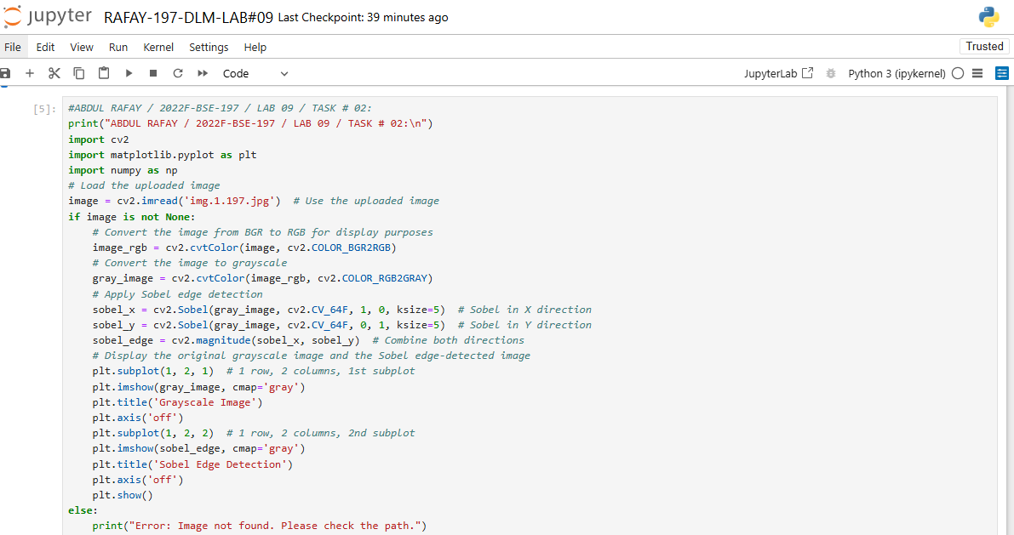

* **OUTPUT:**

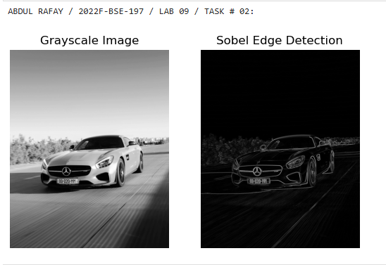

* **GITHUB UPLOAD:**
* **KAGGLE UPLOAD:**